Application Instructions:
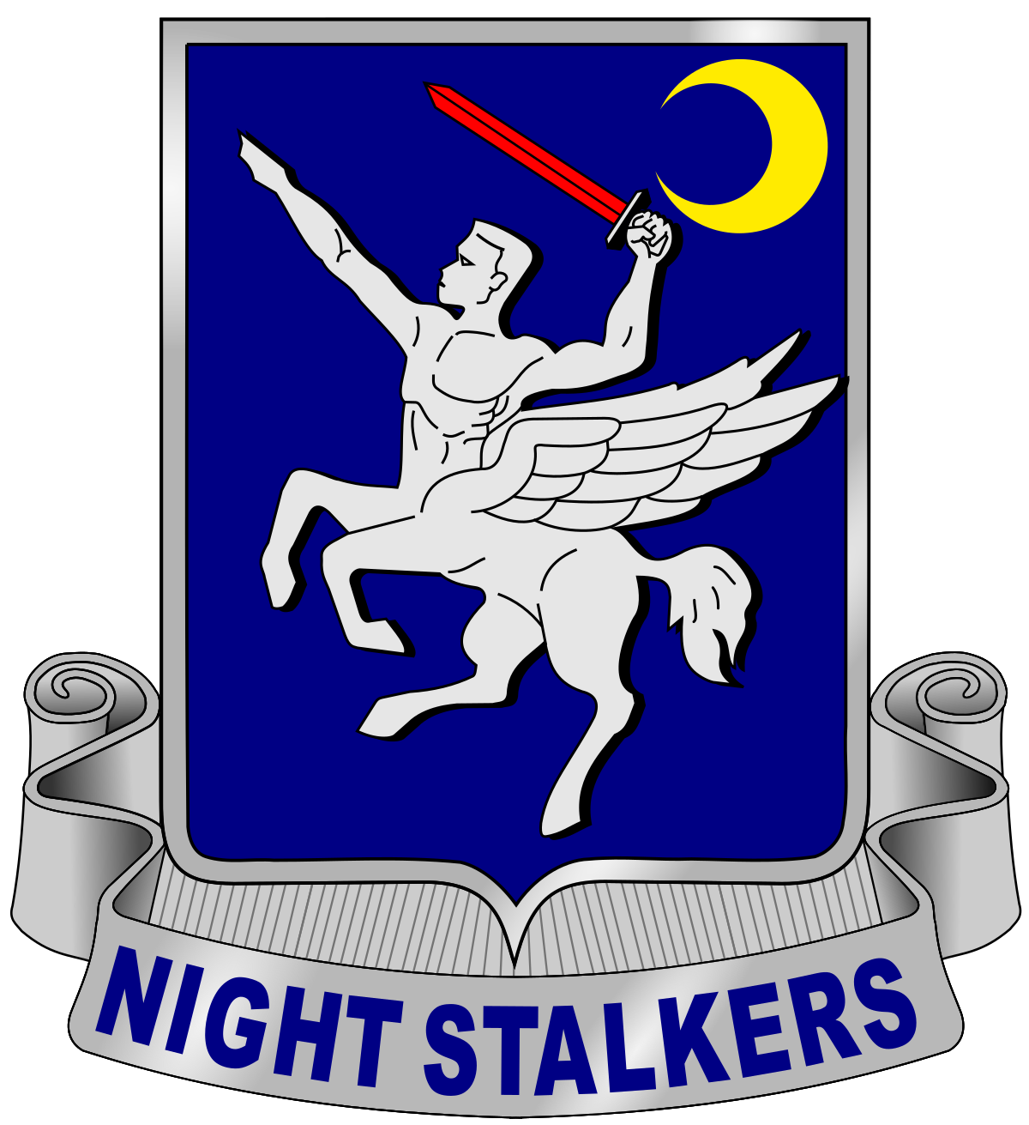
Thank you for your interest in becoming a member of the 160th Special Operations Aviation Regiment (Airborne). This application is your first step to a fulfilling career in the Special Operations Aviation community. The purpose of this application is to determine your eligibility for assignment with 160th SOAR(Abn) based on Army requirements, as well as to gauge your responsibility, maturity, emotional stability, and professionalism prior to arriving at Enlisted Combat Skills Training.

It is imperative that you answer each question completely and truthfully. Responses to these questions are not automatically disqualifying but may require further evaluation. Please provide clear, complete details for any required explanations (dates, situational details, outcome, etc.).

Information obtained in this survey resulting from your truthfulness will only be available to the 160th SOAR(Abn) Application Review Team. This information will be used solely for the purpose of determining eligibility for assignment to 160th SOAR(Abn) and is not disclosed to anyone outside of the Application Review Team.

Your answers to this survey are official statements pursuant to Article 107, Uniform Code of Military Justice. False statements will result in disqualification for assignment and could subject you to punitive and/or adverse administrative action.

Required Packet Documents:

- Copy of a current SRB/STP (within 30 days)
- Copy of a current ACFT Scorecard
- Copy of your last three Army Body Composition Worksheets (if applicable)
- Copy of any profiles (if applicable)
- Copy of your last three NCOERs (if applicable)
- 15R/T/U optional documents: DA Form 2992/DA Form 759

Upon completing this application, please contact your 160th SOAR(Abn) Recruiter to submit your application. If you need to locate a 160th SOAR(Abn) Recruiter, you can find a map of recruiter locations at https://go160thsoar.com. Your recruiter will review your application packet for all required documents and will submit the application packet to the Application Review Team and maintain communication with you throughout the application review process.

Night Stalkers Don’t Quit!
Soldier Information
Date:
Last Name:
First Name:
MOS:
Rank:
DODID:
SSN:
GT Score:
Work Phone:
Cell Phone:
Military Email (optional):
Personal Email:
Current Unit:
Supervisor Name:
Supervisor Email and Phone:
Duty Location:
Duty Location Ranking
Please rank your preferred duty station from 1 to 3:
 |  | Fort Campbell, KY (HHC, 1st BN, 2nd BN):
 |  | Hunter Army Airfield, GA (3rd BN):
 |  | Joint-Base Lewis McChord, WA (4th BN):
Do you have any circumstances that affect your ability to serve in any duty location? |  |  |  |  |  | □ Yes |  | □ No
If YES, explain:
Recruitment Information
How did you hear about 160th SOAR(Abn)? Please list all applicable recruitment sources.
160th Recruiter:
Current Night Stalker:
Former Night Stalker:
Website/Social Media:
160th Career Briefing:
Supervisor/Colleague:
Professional Information
Provide any relevant information that may be useful to the Application Review Panel (this section is optional):
Short-term Goals:
Long-term Goals:
Additional Skills/Qualifications:
Background Information
1. Are you a U.S. Citizen? |  |  |  |  |  | □ Yes |  | □ No
2. Do you hold, or have you applied for, a SECRET or higher security clearance? |  |  |  |  |  | □ Yes |  | □ No
3. Will you have 3 years remaining in service upon assignment? |  |  |  |  |  | □ Yes |  | □ No
4. Do you have a permanent profile? |  |  |  |  |  | □ Yes |  | □ No
If YES, submit a copy of your permanent profile with your application.
5. Have you ever been hospitalized? |  |  |  |  |  | □ Yes |  | □ No
If YES, explain:
6. Do you have any pre-existing injuries or conditions? |  |  |  |  |  | □ Yes |  | □ No
If YES, explain:
7. Do you currently require a Body Fat Content Worksheet (DA Form 5500/5501)? |  |  |  |  |  | □ Yes |  | □ No
If YES, submit your current Body Fat Content Worksheet (DA Form 5500/5501) with your application.
8. What is your current ACFT Score?
Score: |  |  | Date: | Ht/Wt:
9. Do you have any dependents in the Exceptional Family Member Program (EFMP)? |  |  |  |  |  | □ Yes |  | □ No
10. Are you enrolled in the Married Army Couples Program (MACP)? |  |  |  |  |  | □ Yes |  | □ No
11. What is your marital status? |  |  |  | □ Single | □ Married |  | □ Divorced
12. List your total number of dependents:
13. Are you a single parent with primary physical custody? |  |  |  |  |  | □ Yes |  | □ No
If YES, explain:
14. Are you a single parent without primary physical custody, but have visitation rights? |  |  |  |  |  | □ Yes |  | □ No
If YES, explain:
15. If you had to reenlist today, would you? |  |  |  |  |  | □ Yes |  | □ No
If NO, explain:
16. How long do you intend to stay in the Army?
17. Are you/have you ever been part of an organization that supports overthrowing the U.S. Government? |  |  |  |  |  | □ Yes |  | □ No
If YES, explain:
18. Are you/have you ever been a dual citizen of the U.S. and another country? |  |  |  |  |  | □ Yes |  | □ No
If YES, explain:
19. Are any of your immediate family members non-U.S. citizens? |  |  |  |  |  | □ Yes |  | □ No
If YES, explain:
20. Do you or any of your immediate family members have foreign property or foreign financial interests? |  |  |  |  |  | □ Yes |  | □ No
If YES, explain:
21. Have you ever experienced financial difficulties that resulted in bankruptcy, repossession, tax lien, wage garnishment, judgment, or collection accounts? |  |  |  |  |  | □ Yes |  | □ No
If YES, explain:
22. List your total credit card/unsecured debt. Do not include mortgage/student loans.
23. Have you ever had any alcohol-related arrests, treatment, or counseling? |  |  |  |  |  | □ Yes |  | □ No
If YES, explain:
24. Have you ever been denied a security clearance or had one revoked? |  |  |  |  |  | □ Yes |  | □ No
If YES, explain:
25. Have you ever used, possessed, bought, sold, or transferred any illegal narcotic, depressant, stimulant, hallucinogen, cannabis, or any other illegal drug or controlled substance? |  |  |  |  |  | □ Yes |  | □ No
If YES, explain:
26. Have you ever been suspected of, charged with, or convicted of any felony offense? |  |  |  |  |  | □ Yes |  | □ No
If YES, explain:
27. Are there currently any charges pending against you for a criminal offense(s)? |  |  |  |  |  | □ Yes |  | □ No
If YES, explain:
28. Have you ever been the subject of any inquiry involving the loss or mishandling of classified information or material? |  |  |  |  |  | □ Yes |  | □ No
If YES, explain:
29. Have you ever been absent without leave (AWOL)? |  |  |  |  |  | □ Yes |  | □ No
If YES, explain:
30. Have you ever been fired from a job? |  |  |  |  |  | □ Yes |  | □ No
If YES, explain:
31. How many times have you been late for work in the last 12 months?
32. Briefly explain your opinion of military intervention in a foreign country as an extension of U.S. foreign policy.
33. Do you agree with the current U.S. policies in the Global War on Terror? |  |  |  |  |  | □ Yes |  | □ No
If NO, explain:
34. Have you ever been treated by any mental health professional or other counselor, social worker, psychologist, or psychiatrist? |  |  |  |  |  | □ Yes |  | □ No
If YES, explain:
35. As an adult, have you ever purposely damaged or vandalized property that did not belong to you? |  |  |  |  |  | □ Yes |  | □ No
If YES, explain:
36. Have you ever been suspended or expelled from school? |  |  |  |  |  | □ Yes |  | □ No
If YES, explain:
37. Have you ever been associated with a gang or any other racist/extremist organization that used or advocated intimidation or violence against others? |  |  |  |  |  | □ Yes |  | □ No
If YES, explain:
38. Do you have any phobias or extreme fears? |  |  |  |  |  | □ Yes |  | □ No
If YES, explain:
39. Have you ever failed to support any children, abandoned them, or failed to pay child support? |  |  |  |  |  | □ Yes |  | □ No
If YES, explain:
40. Have you ever abused or neglected a child or been investigated for abuse or neglect of a child? |  |  |  |  |  | □ Yes |  | □ No
If YES, explain:
41. Have you ever willfully disobeyed any law or regulation because of your personal beliefs? |  |  |  |  |  | □ Yes |  | □ No
If YES, explain:
42. Have you ever been diagnosed with attention deficit/hyperactivity disorder or a learning disorder? |  |  |  |  |  | □ Yes |  | □ No
If YES, explain:
43. Have you ever been arrested, even if not formally charged? |  |  |  |  |  | □ Yes |  | □ No
If YES, explain:
44. Have you ever been suspected of, accused of, charged of, or convicted of domestic abuse or been referred to social work services resulting from a domestic incident or any other type of incident? |  |  |  |  |  | □ Yes |  | □ No
If YES, explain:
45. Have you ever received a summarized, company grade, or field grade Article 15? |  |  |  |  |  | □ Yes |  | □ No
If YES, explain:
46. Have you ever been issued a letter of reprimand at any level? |  |  |  |  |  | □ Yes |  | □ No
If YES, explain:
47. Have court-martial charges ever been preferred against you at any level? |  |  |  |  |  | □ Yes |  | □ No
If YES, explain:
48. Have you ever attempted or seriously considered suicide? |  |  |  |  |  | □ Yes |  | □ No
If YES, explain:
49. Have you ever been prescribed any psychotropic or psychiatric medications? |  |  |  |  |  | □ Yes |  | □ No
If YES, explain:
50. Have you ever been discharged from any branch of the military for any reason? |  |  |  |  |  | □ Yes |  | □ No
If YES, explain:
51. Have you ever been assigned to 160th SOAR(Abn), Hold Platoon or Enlisted Green Platoon? |  |  |  |  |  | □ Yes |  | □ No
If YES, explain:
52. Have all your answers been completely truthful? |  |  |  |  |  | □ Yes |  | □ No

